Waves and Sounds

Introduction

For this activity, we will explore the key components of waves and sound using the iPad custom applications, Waves & Sound and SoundSynth. You will be able to see and hear how changing these parameters alters the audio and the waveform.

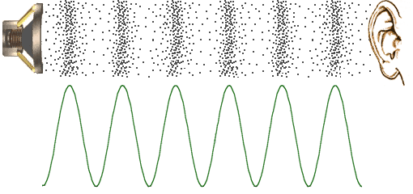


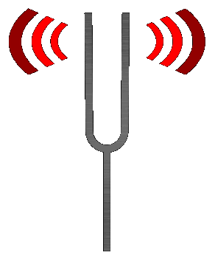
Where do we observe waves in the real world?

What is sound?

So...if a tree falls in the forest, and no one is around to
hear it...does it still make a sound?

Materials

You will be given the following materials for this activity:

- iPad
- Headphones (or you can use your own)
- Pen / Pencil

Sine Waves

Sine waves are the building blocks of sound. In fact, ALL signals can be created by combining sine waves.

Sine Wave = Frequency

Cycle = One repetition of a wave’s pattern
Frequency = The number of cycles per second (measured in Hz)
Period = Time duration of one cycle (the inverse of frequency, P = 1/ f)
Wavelength = The length of one period of a wave
Amplitude = A measure of it’s change over a single period

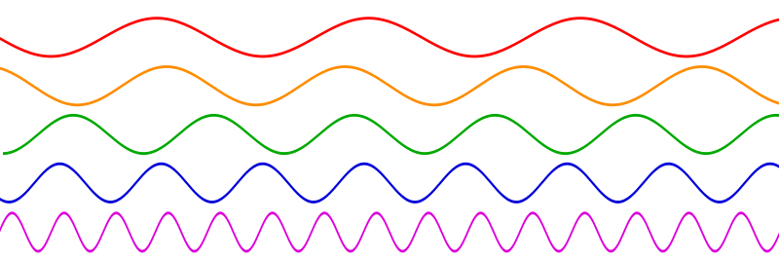
Figure 1: Five sine waves (X-axis = time, Y-axis = amplitude)

- Draw lines on each of the sine waves, splitting them into single cycles.

- The sine wave with the highest frequency is _____________, and the sine wave with
the lowest frequency is _______________.

- The sine wave with the shortest period is _________________, and the sine wave
with the longest period is ______________. (*remember Period = the inverse of
frequency)

- The sine wave with the shortest wavelength is ________________, and the sine
wave with the longest wavelength is ___________________.

- What relationships exist between frequency, period, and wavelength?

Using an iPad to Generate Waveforms

We used to need a ton of bulky hardware to create these signals (oscilloscope, function generator, cables, and a speaker). Now, we can do all of this using software.

- Open the Waves & Sound app on the iPad. This app allows you to choose a
waveform and change the amplitude and fundamental frequency parameters.

Figure 2: Waves & Sound App

- Using your headphones, take a couple of minutes to explore the different waveforms
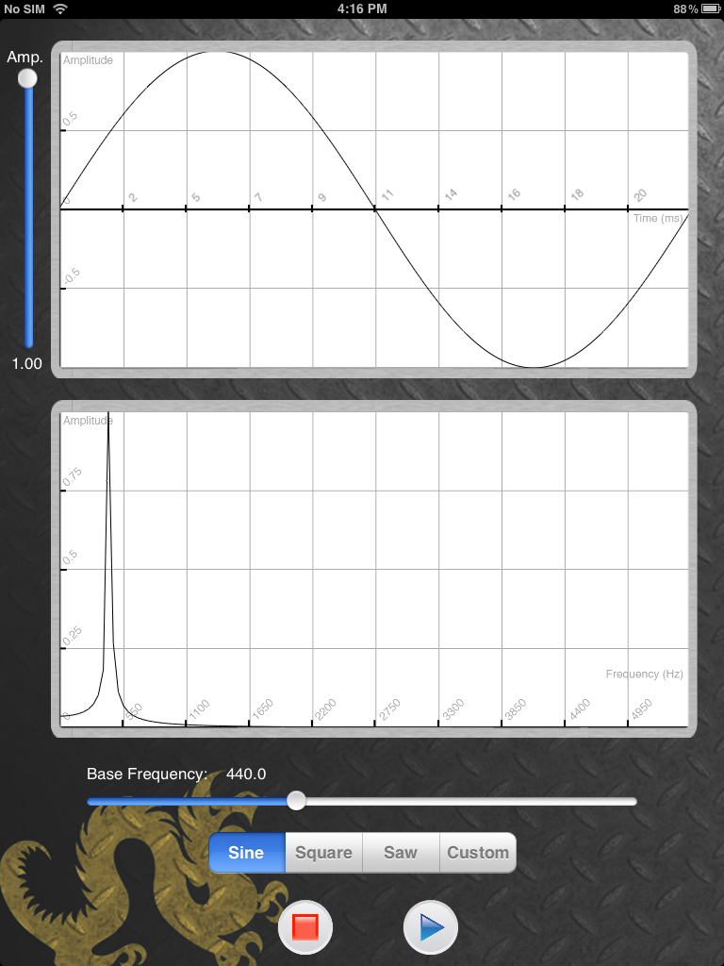
(sine, square, saw). Also, you can tweak the amplitude and fundamental frequency.
To hear your waveform, press the play button.

** Adjust the volume on the iPad to avoid uncomfortably loud tones before hitting
play.

- What changes to the sound occur when you:
Change waveforms? Raise/lower the amplitude? Alter the fundamental frequency?

- Can you create a sine wave with a frequency of 500 Hz and an amplitude of 0.5? A
square wave with a frequency of 800 Hz and an amplitude of 0.7.? A saw wave with
a frequency of 300 Hz and an amplitude of 0.4?

Signal Analysis on iPad

Sine waves are the building blocks of sound. In this activity, we will take a closer look at sine waves and their properties. While exploring the Waves and Sound app, you heard and saw different types of waveforms. Something you may not have been able to guess from seeing and hearing these different signals is that they can all be created by combining simple single frequency sin waves. Remember ALL signals can be created by combining sine waves.

Signal Analysis

- We will be using the Waves & Sound app again. The top window displays the
waveform and displays time in milliseconds. The bottom window shows the
frequency spectrum (Hz).



- Make sure you select “Sine”. On the waveform plot, you should see one period of
a sine wave.

- Move the frequency slider under the frequency spectrum until the frequency value
is set as close to 500 Hz as possible.

4. Where do you see the peak in the frequency spectrum? ___________________

- How many frequencies occur in a sine wave? ____________

Square and Sawtooth Waves

(a) Square Wave (b) Sawtooth Wave

Figure 3: Example Waveforms

The spectrum shows us the frequencies and amplitudes (height of the peak) of the sine wave needed to create the waveform. Let’s explore some of those complex waveforms you saw earlier.

- Select square wave. Set the frequency to 500 Hz (or as close as you can get).
Raise the amplitude to 1.00 to see higher peaks in the frequency spectrum.

- You should notice that for the square wave there are peaks for more than one
frequency in the spectrum. How many sine waves does it take to make this
wave? ________ How does this sound different from a sine wave?

- Estimate the values in Hz for the 4 peaks beyond the fundamental frequency.
(Hint: they should be multiples of the fundamental frequency)

4. Peak 1 = ______ Peak 2 = _______ Peak 3 = _______ Peak 4 = ________

- Is there a pattern or relationship you notice in the frequencies (Hz) of a square
wave? What happens to the amplitudes of the peaks as the frequencies increase?

- See if you can draw your own square wave by using your finger in the waveform
plot. Do you see the same patterns? (See Fig 3.)

Fundamental Frequency = the lowest frequency of a sound, and usually the most dominant frequency.

- Now, select saw wave. Keep the frequency at 500 Hz and leave the amplitude at 1.00.

- How many sine waves make up the sawtooth wave? ______ How did the sound
change?

- Estimate the values of the peaks beyond the fundamental frequency.

- Peak 1 = _____ Peak 2 = _____ Peak 3 = _____ Peak 4 = _____ Peak 5 = ____

Peak 6 = _____ Peak 7 = _____ Peak 8 = _____ Peak 9 = _____

- What is the pattern you notice for the frequencies (Hz) of a sawtooth wave?

12. See if you can draw your own sawtooth wave in the waveform plot. (See Fig 3.)

Draw your own Waveform

The next activity will demonstrate how ANY waveform can be reduced to individual sine waves. Each group will be drawing their own waveform, taking note of how the wave looks and sounds. Then, using the SoundSynth application, students will attempt to recreate their waveform by carefully using the information in the frequency spectrum and mapping the frequencies and amplitudes onto the SoundSynth frequency spectrum.

- For this activity, everyone needs a partner. One partner needs to open Waves &
Sound, and the other partner should open SoundSynth.

- As you have seen, the Waves and Sound app gives you the option of creating your
own waveform, by using your finger to draw in the waveform window.

- One team member will draw a wave and choose a fundamental frequency in the
Waves & Sound app.

- Next, on the other iPad, teams will work together to recreate the frequency spectrum
in the SoundSynth app, using the information from the frequency spectrum in the
Waves & Sound application (where you drew your wave).

- Do the two waveforms that you have created sound the same?

Do the two waveforms look the same?

Harmonics

The peaks beyond the fundamental frequency in the last activity area called harmonics. While a sine wave is a pure tone, made of only one frequency, other waves (square, sawtooth, etc.) are made up of a sin wave and its harmonics. The harmonics of a frequency are just integer multiples of the fundamental frequency. As you saw in the last activity, if our fundamental frequency is 100 Hz, then our 2nd harmonic is the fundamental frequency multiplied by 2 (100 Hz x 2 = 200 Hz). We are going to explore harmonics using the SoundSynth iPad application.

1. Open the SoundSynth application on the iPad

Figure 4: SoundSynth iPad app

- You should see the waveform and frequency spectrum again. On the bottom of the
screen, you will see a slider which controls the fundamental frequency. Set this to
220 Hz.

- Raise the amplitude of the left most dot on the frequency spectrum (this controls
the amplitude of the fundamental frequency). This is an example of a pure tone or
_________ wave, which we discussed earlier.

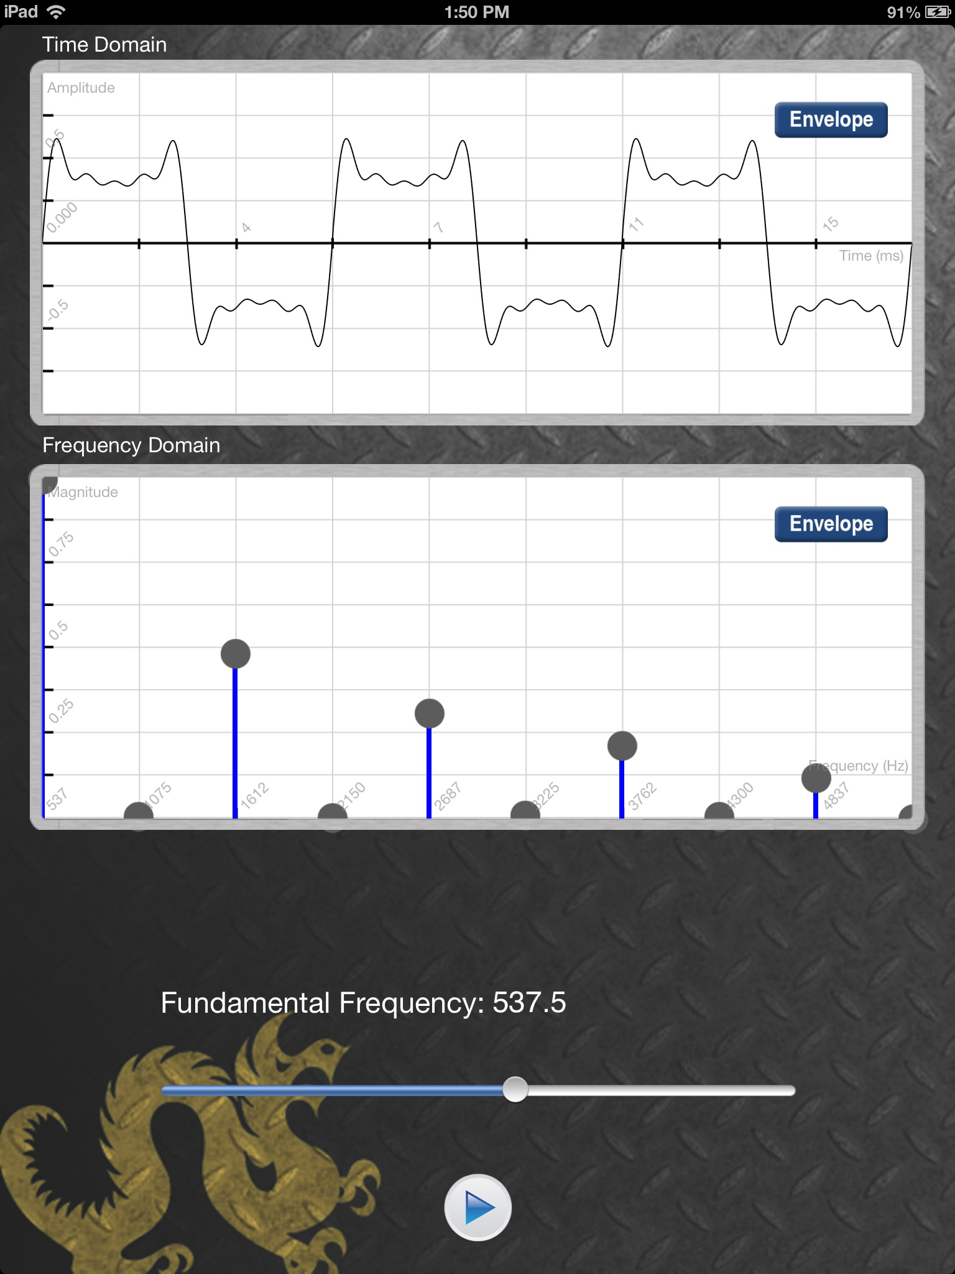
- To create a mixed tone, we need to add another sine wave. Find the dot which is
directly to the right of the fundamental. Raising and lowering this dot controls the
amplitude of our 2nd harmonic. Look at the frequency label under the dot on the
frequency spectrum.

What is the relationship between this value and our fundamental frequency?

- Raise this slider to the top, giving us the maximum amplitude.

What does this new tones sound like? Do you hear two distinct tones or one
blended tone?

- Move the amplitude and fundamental frequency sliders around and see what types
of tones you can create.

Find the Harmonics Game

- For this game we will use the Waves & Sound iPad app.

- We will not be using headphones for this activity.

- Select sine wave.

- The instructors will ask a student to generate a specific fundamental frequency.

- The first goal is to have everyone, using their ears, to match the frequency.

- Once the group has found the fundamental frequency, it should be easy to generate
the harmonics. Each person will be assigned a different harmonic. Once everyone
is at their correct frequency, we should hear a the combinations of frequencies as a
blended single tone.

Some “Cool” Applications of Sound

- The average range of human hearing is from 20 Hz to 20,000 Hz (20 kHz). As we
get older or damage our hearing (lots of loud music, etc.), that range decreases. You
can test your own hearing at www.onlinetonegenerator.com

My hearing range is from: ______ Hz to _______ Hz

There is a ringtone called the “Mosquito Ringtone” that older people can’t hear
because it rings at very high frequencies.
http://www.noiseaddicts.com/2011/06/mosquito-ringtones/

- We can generate a frequency spectrum from whole songs, not just individual
waveforms. Let’s look at a spectrum analyzer visualization for some real music in
iTunes. This visualization shows the left/right frequencies and amplitude of the
music as it is playing.

